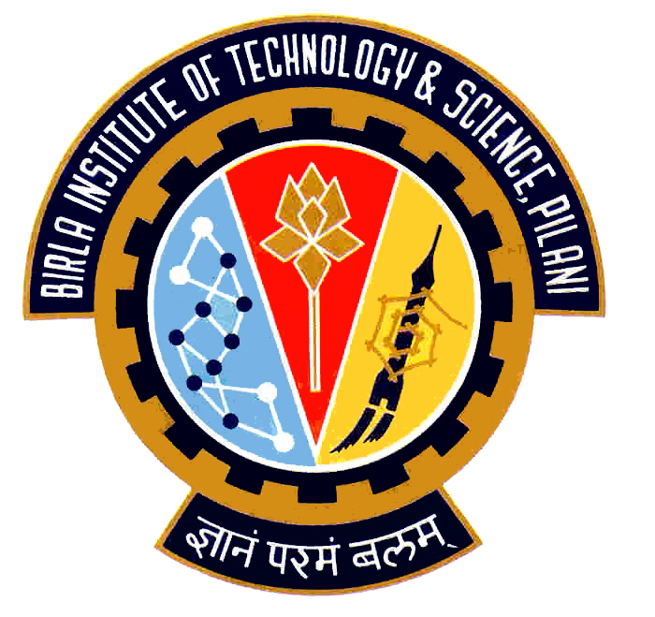

Election Commission

Birla Institute of Technology & Science – Pilani, Goa Campus, Zuarinagar, Goa-403726, INDIA
Tel: (0)98233 6368 Fax:0832-2557033

Final List of Candidates for Hostel Representatives:

CH 1

CULTURAL
ANMOL SHARMA | 2007S3P8444
HOSTEL AND CAMPUS MANAGEMENT
DEEPAK MEHTA | 2007P7PS062
TANAY AGRAWAL | 2007P1PS100
P. SREE CHARAN TEJ | 2007P3PS152
MESS
BISWAS KUMAR SINHA | 2007T6PS473
ANSHUMAN KHIMKA | 2007P7PS117
B. KRISHNA MOHAN | 2007P3PS191
VINEET P. KAIMAL | 2007P3PS001
SPORTS
N. DILEEP REDDY | 2007P4PS321
VIKAS JANGRA | 2007P4PS241

CEC Chief Warden

